Social Event: Baidu Party
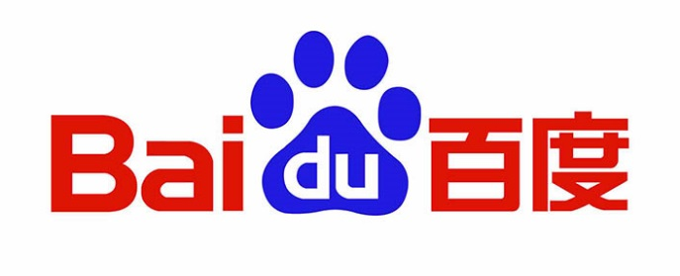
- »Time: 16:00-20:00, 1st Sept.
- »Location: Baidu Building
- »Participants: all are welcome (about 40 people)
- »Description: Get a tour of the world’s largest Chinese search engine. Share experience with Baidu researchers and engineers about how to build and operate the system handling hundreds of millions of requests per day. Enjoy a buffet dinner with Baiduers.
- »Company Information: Baidu was founded in 2000 by Internet pioneer Robin Li, creator of visionary search technology Hyperlink Analysis, with the mission of providing people with the best way to find information and connect users with services. Over the past decade we have strived to fulfill this mission by listening carefully to our users' needs and wants. To provide intelligent, relevant search results for the tens of billions of queries that are entered into our search platform every day, we focus on powering the best technology optimized for up-to-date local tastes and preferences. Our deep understanding of Chinese language and culture is central to our success and this kind of knowledge allows us to tailor our search technology for our users' needs.

If you wish to participate this activity, please fill in the following form and send this document to icpp2015@cernet.edu.cn before August 16th.
Please note: because of limited places, we will make the selection according to the email order.
Last name
First name
Registration ID
Email
Phone
(mobile phone preferred)

